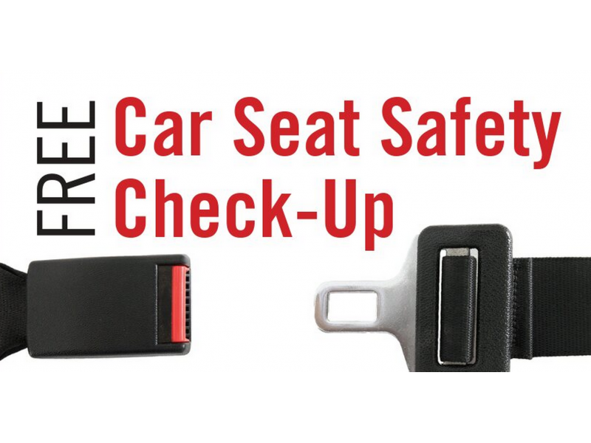
95% of child safety seats are misused

Is your child’s car seat properly installed?
Is your child in the appropriate seat?
Has your child’s car seat been recalled?
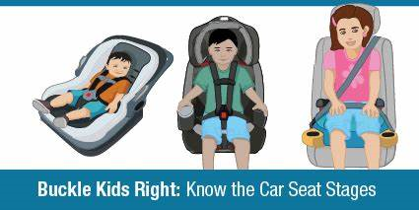

Have your child seat checked for FREE by a certified car seat technician

Appointments preferred!

Date/Time: Saturday September 21, 9am-1pm
Location: West Bradford Fire Company Sub Station
1385 Campus Drive Downingtown, PA 19335
- Marshallton-Thorndale Road and Poorhouse Road -
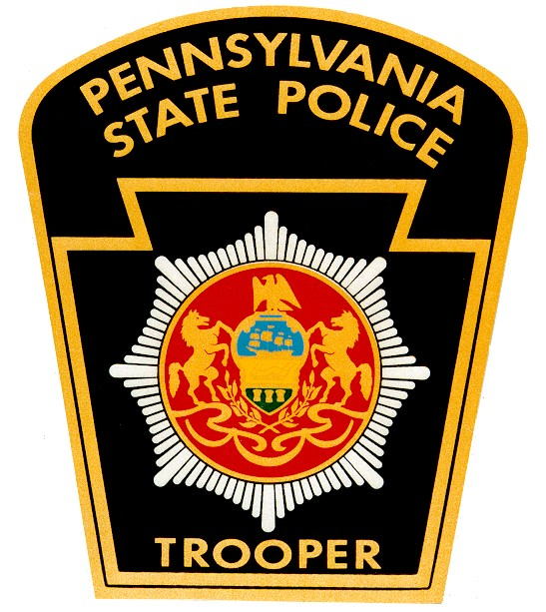
Questions? Contact Corporal Jason Pennington at 610-486-6092

